Remove The Double Agents

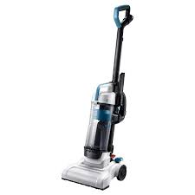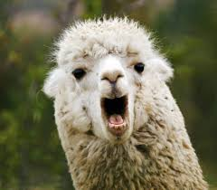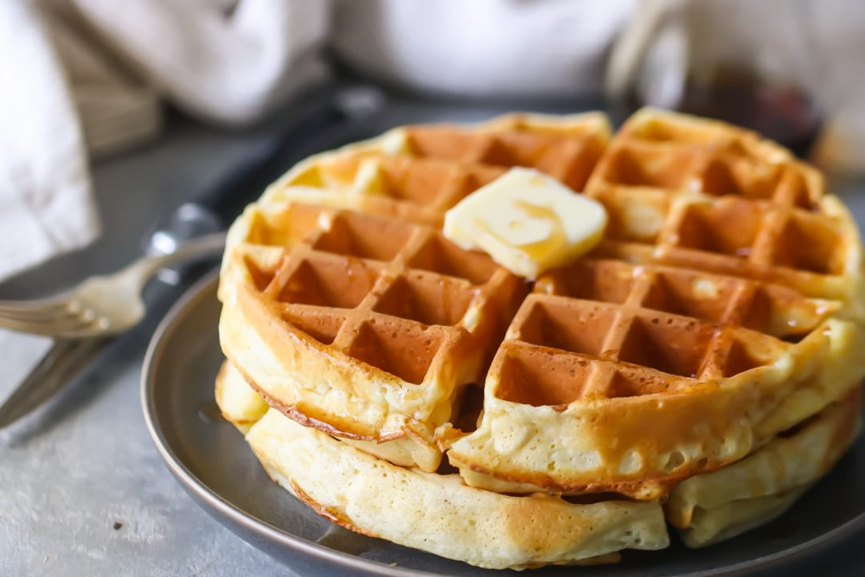

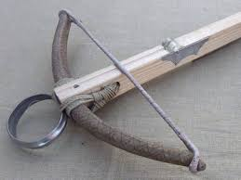

|  |  |  |  |  |  |  |  |  |  |
| --- | --- | --- | --- | --- | --- | --- | --- | --- | --- |
| P | U | S | C | H | O | S | X | T | M |
| L | F | H | K | B | U | K | F | S | B |
| Z | M | S | B | O | F | H | N | X | L |
| U | H | P | T | P | X | S | U | Z | K |
| C | L | F | B | F | A | T | K | R | S |
| U | F | U | L | T | S | H | X | T | P |
| X | D | B | O | X | L | R | S | F | L |
| H | S | H | U | K | T | S | B | H | U |
| F | T | G | S | B | L | E | F | X | M |
| U | K | X | P | X | F | H | P | Z | F |

Alphabetical key: ____ ____ ____ ____ ____ ____ ____